Vibudh Singh – 98716913

6 In-class exercises

Consider the following data, decision boundary, and margin boundaries.

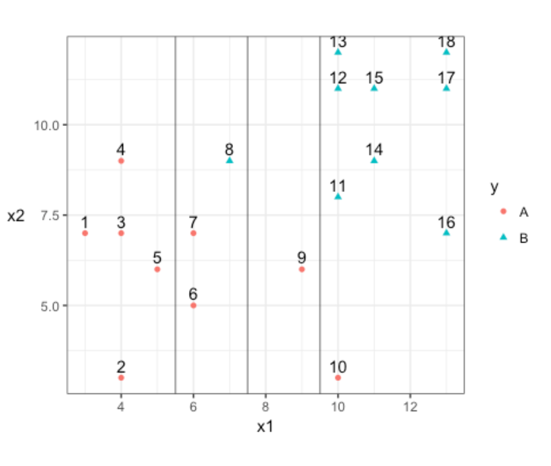

1. Construct the decision rule according to this classification boundary. How would you classify a new observation that has x1=6 and x2=10?

Ans. A

Sol. X1>7.5

1. What size is the margin here?

Ans. 1.5  
2

1. Which observations receive a penalty? Which observations are the support vectors?

Ans. 8 and 9

6,7,8,9,10

1. What is the total penalty here?

Ans.   
For 8, penalty = 0.5  
For 9, penalty = 1.5

7, 0.25  
6, 0.25  
8, 1.25  
9, 1.75  
10. 2.25

1. Can I choose a bigger margin if my total allowable penalty is 6?

Ans. No, because if we choose a bigger margin. The penalty will be over 6.

1. Are the data separable? If so, what are the support vectors

Ans. The data is not separable.   
The support vectors are 6, 7, 8, 9, 10, 11, 12 and 13

Yes. Tilted line

Support vectors – 4, 8 and 9

SVC will choose this over the other one if we allow penalty of 6. That is why we choose a stricter penalty.